WATER
Given water’s central role in society and the environment, and the pressures and challenges facing water supply in the Australian Capital Territory (ACT), it is imperative that the condition of the Territory’s water resources is monitored, assessed and, consequently, managed effectively.

Measuring water resources in the ACT
To assess how water resources in the ACT are responding to pressures from land use, climate and water resource development, a range of water-related indicators were examined. Data on these indicators are collected at different places and times throughout the Territory to provide an assessment of the current condition (state) of water resources in the ACT and how their condition is changing over time (trend). The following indicators were used to assess the amount, quality and ecological condition of waters in the ACT:
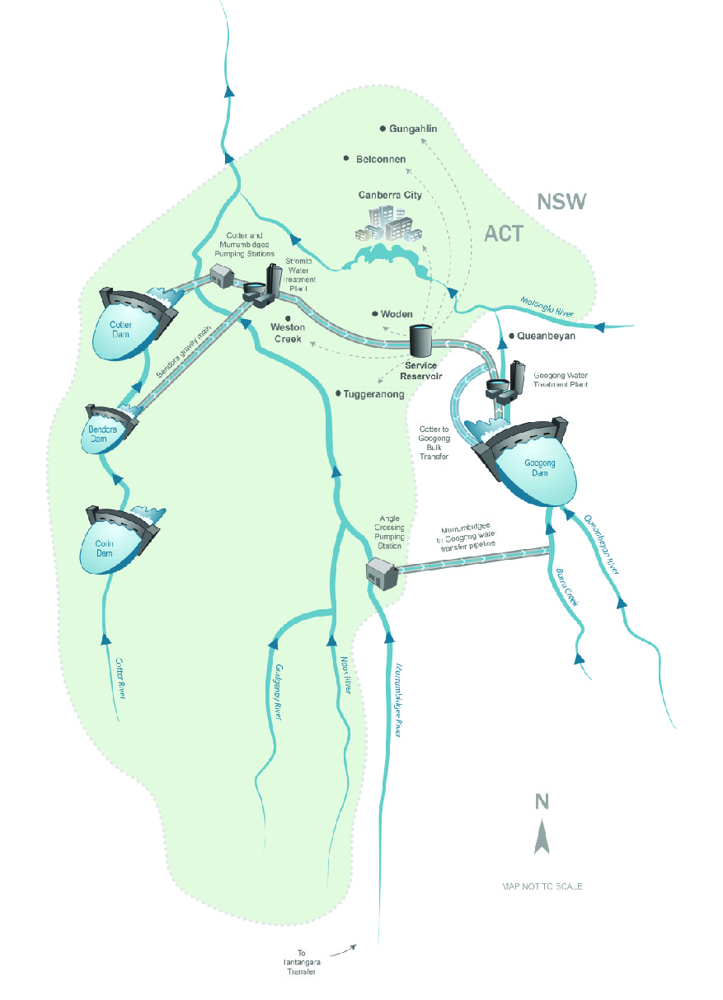ACT Water Supply network. The ACT draws water from 3 separate catchments – Cotter, Queanbeyan and Murrumbidgee River Catchments Source: Icon Water

Insert map (Fig 6.10 from SoER with caption: (IF IT FITS)!
The ACT draws water from 3 separate catchments – Cotter, Queanbeyan and Murrumbidgee River Catchments

State and trends
- Surface water quality
- Ground water quality and availability
- Drinking water quality
- River flow
- River condition

Pressures
- Climate change and variability
- Land use and management
- Water resource development

MAIN FINDINGS

State and Trends

Surface water quality
Water quality is regularly assessed using nine indicators prescribed by regulatory guidelines. The results of these assessments are summarised in Table 1.
Table 1: Water quality state and trend 2011-15
Indicator | Summary of results | Against 2007-11
Overall Surface Water quality | Good – the average of all measures indicates that overall surface water quality has improved. | Improved
Conductivity | Very good- Levels exceeded guideline levels at 9.5% of sites, mostly in areas influenced by urban land use. | Steady
pH | Very good - pH values outside guideline range infrequently (only 2% of samples) | Steady
Dissolved Oxygen (DO) | Very good - 0.4% of samples below guideline levels. Higher levels in areas of land clearance and soil erosion. Turbidity is also influenced by colouration eg colouration from tannin rich streams in Namadgi National Park. | Steady
Turbidity | Poor - 40% of samples exceeded the turbidity guideline | Improved
Phosphorous | Very good - Total phosphorus exceeded guideline levels in 6.4% of samples mostly in areas of increased erosion from land clearing. | Improved
Nitrogen | Very poor - 77% of samples exceeded the total nitrogen level guideline in areas where higher amounts of pollution eg fertiliser enter waterways. The high levels of nitrogen recorded are also affected by anomalies with the current guidelines. | Improved
Suspended solids | Good - Exceeded guideline levels in approximately 11% of samples primarily in areas of land clearing and soil erosion. | Improved
Faecal coliform | Good - Higher than guideline levels found in approximately 20% of samples. Samples were only taken in areas of concern eg urban. Results likely to be due to urban run-off and animal access. | Improved
Chlorophyll-a | Poor - Levels higher than guideline levels were found in around 31% of samples. Probably due to high nutrient levels from urban run-off. Samples also affected by normal seasonal fluctuations in platonic biomass – these are independent of flow rates or exceptional nutrient loads. | Improved

Ground water quality and availability
From the information available and data collected in previous assessment periods, it is likely that groundwater availability and quality are good in the ACT, with negative trends unlikely. However it is likely that groundwater is being extracted at far below the rate that recharge is replenishing aquifers. For example, groundwater extraction in the ACT was approximately 0.5 gigalitres per year in 2004–05, which represents a very low level of stress on aquifers in the ACT. It is estimated that the extraction rate is no greater than 10% of the long-term recharge.

Drinking water quality
Drinking water in the ACT is of very high quality and is consistently within standards in the Australian Drinking Water Guidelines. In 2011–2015, drinking water quality, on average, met the standards in the Australian Drinking Water Guidelines. On a small number of occasions, pH, chlorine and turbidity slightly exceeded Australian Drinking Water Guidelines standards. The results for 2011–2015 are similar to those for 2007–2011.
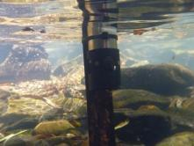
Underwater photo of a turbidity logger in Condor Creek
Photo: University of Canberra

River Flow
The quantity of water flowing into and out of the ACT is a major determinant of waterway ecological condition. The natural flows in ACT streams are highly variable and mainly altered by water resource development, such as the building of dams and weirs, and diversion or extraction of in-stream flows. Similar amounts of water enter and leave the ACT, primarily because of contributions from the Cotter River Catchment and urban run-off.

River condition
Water leaving the ACT via the Murrumbidgee River should be of the same quality as, or better than, water entering the ACT. In 2011–2015, chlorophyll-a, faecal coliforms, conductivity, turbidity and total nitrogen all exceeded water quality guideline levels more often downstream of the ACT at Halls Crossing then they did upstream of the ACT at Angle Crossing. This is an increase of all measurements since 2007–2011.
The Australian River Assessment System (AUSRIVAS) uses aquatic macroinvertebrates to provide information about river health using nationally standardised methods and analysis protocols. Overall, the ecological condition (macroinvertebate O:E scores) in the ACT is in a poor state. This finding however must take into account the fact that most sampling occurs in areas heavily affected by land use and water resource development pressures (e.g. dams).

Pressures
To assess how human activities put pressure on ACT water resources were considered:

Land use and management
Surface water quality indicators in the ACT, related to land use, such as total nitrogen, turbidity and chlorophyll, are all in a poor state or worse, with a high percentage of samples exceeding water guideline levels. While it is difficult to link the poor state of these indicators with specific areas or events, it is likely that these conditions are, in part, caused by land-use pressures, in particular, run-off carrying sediments and pollutants (e.g. fertilisers) from urban and agricultural areas.
Land-use pressures on groundwater quality were assessed as low during the reporting period, but this may change if pollution of surface water sources persists and intensifies.
Pressures placed on ACT drinking water quality by land use are minimal, because the majority of water catchments are in protected conservation areas.
In the ACT, the poor overall state of macroinvertebrate communities in 2011–2015 suggests that there are substantial land-use pressures affecting ecological condition. However, it is important to note that the macroinvertebrate indicators showed some small improvements relative to 2007–2011.

Climate variability and change
Climate variability and change influence the amount of water flowing into ACT rivers (river discharge), and in turn, the amount of water that recharges groundwater aquifers, through fluctuations in rainfall and temperature.
During 2011–2015, climate variability and change pressures on river discharge in the ACT were minimal. Based on available data, river discharge was in a very good state.
Currently, there appears to have been little pressure on groundwater availability from climate variability and change in the ACT. However, as with river discharge, this could change if rainfall declines.
The current poor state of ecological condition (from AUSRIVAS O:E scores) may, in some way, be linked to pressures from climate variability and change. However, because macroinvertebrate responses represent an integrated measure of various disturbances, it is difficult to discern the specific role of climate variability and change.

Water resource development
Water resource development (eg dams, water extraction, stream-flow regulation) is critical for the predictable supply of water. Through damming and water extraction, water resource development changes a river’s flow regime by altering the rate, amount, timing, magnitude, frequency and duration of flows. Dams and water extraction in the ACT have substantially changed river flow regimes in the ACT, with decreases in the amount of flows in some areas (eg Cotter and Queanbeyan rivers), and increases in the frequency and duration of low-flow events.
The pressure placed on ecological function by river regulation in the ACT is managed through environmental flow allocations, which have been effective in maintaining functioning ecological communities (fish, macroinvertebrates and algae). In 2011–2015, ecological condition (AUSRIVAS O:E score) downstream of dams on the Cotter River (Cotter and Corin) and Queanbeyan River (Googong Dam) was assessed as significantly impaired, but similar to reference (Bendora Dam). Therefore, it is likely that river regulation is having an influence on ecological condition, but the pressure is being offset by environmental flow releases which have been effective in maintaining functioning ecological communities (fish, macroinvertebrates and algae).

Response
Water managers are well aware of the pressures and, in 2011–2015, major progress was made in increasing the ACT’s water storage capacity and establishing integrated catchment management as a fundamental part of water cycle management in the ACT.
In 2011, a review of the 2004 water resource strategy, Think Water, Act Water, found that significant achievements had been made towards the strategy’s objectives, which were focused on:
- increasing the efficiency of water use
- providing long-term reliable sources of water for the act and region, and
- promoting the development and implementation of an integrated approach to ACT – NSW cross-border supply and management.
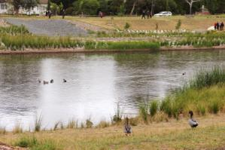
The ACT has many urban water features and green spaces that contribute to ecosystem services, including Dickson Wetland. Photo: ACT Government
The review found that the strategy had successfully guided the ACT to improved water security, and that it was timely to explore potential new strategies for the ACT’s future water needs.
In August 2014, the new ACT Water Strategy 2014–44: Striking the Balance, was released. This strategy focuses on achieving healthy catchments and water bodies; a sustainable water supply that is used efficiently; and a community that values and enjoys clean, healthy catchments. For each of these outcomes, the ACT Water Strategy identifies strategies and actions to guide water management in the ACT for the next 30 years. The strategy will be implemented through five-year implementation plans, and effectiveness will be monitored through identified targets and indicators.

More information on this topic is available in the ACT State of the Environment Report 2015 http://reports.envcomm.act.gov.au/actsoe2015

