LAND
Land – and the social, economic and ecological values it provides – is fundamental to the human activities in the Australian Capital Territory (ACT). Changes to the ways land is used affect land condition, influence many aspects of environmental health, and in turn, our own wellbeing.

Measuring land condition
The state of land in the ACT is assessed through indicators that measure land use and soil condition, and examine the existing and future pressures on Australian Capital Territory (ACT) land.
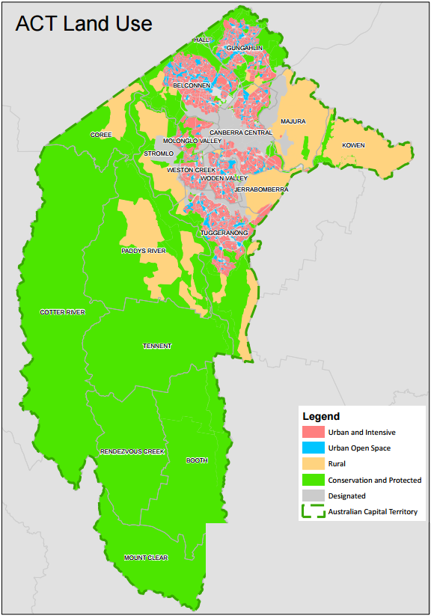
Figure 1: ACT Land use types
Source: ACT Government Environment and Planning Directorate

The following indicators are used to assess state and trends and pressures:

State and trends
- Land use
- Soil condition (soil type and soil properties)
- Contaminated sites
- Compliance with National Environment Protection (Assessment of Site Contamination) Measure (NEPM)

Pressures
- Land-use change (number and type of development applications, and greenfield versus infill development)

KEY FINDINGS

State and Trends

The total area of the ACT is 235 824 hectares (ha), including:
- 17 042 ha (7.2%) zoned for urban and intensive uses, such as residential, industrial and commercial uses
- 32 789 ha (13.9%) zoned for rural purposes, such as agriculture, grazing and plantation forestry
- 170 076 ha (72.1%) zoned for conservation and natural environments, such as nature conservation areas, protected areas and minimal use areas (including water supply catchments).
The report found that Greenfield development occurred on 1420 ha of land between 2011 and 2015.
The ACT has a small agricultural sector located on land zoned for rural use. This land also includes plantation forests managed by the ACT Government. These forests are increasingly used and managed for recreation purposes.
A large percentage of the ACT is used and managed in a way that protects ecological values. For example, 57% of the land of the ACT is in nature reserves and other protected areas. In 2011–2015, approximately 816 ha of land were added to the reserve network.
Data on indicators of soil health such as carbon levels, erosion, acidity or sodicity is scarce. However, soil mapping is currently being conducted, including the mapping of salinity across the ACT. The resulting data should make it possible to report on these indicators in the next ACT State of the Environment Report.
As land development continues, contaminated sites such as former petrol stations, garbage landfills and places where chemical have been used are often found. The number of contaminated sites across the ACT has continued to increase during this reporting period, from 899 to 1014.

Pressures
The key pressures on land in the ACT are changes to land use, particularly greenfield development which typically requires vegetation clearance and other permanent changes. Although the percentage of greenfield development is higher than infill for the 2011 - 2015 reporting period (55%:45%, measured in terms of dwellings built), it is significantly lower than in the previous reporting period (75%:25%). This trend is likely to continue as the ACT Government implements its ACT Planning Strategy (2012) which seeks to prioritise urban infill over greenfield development.

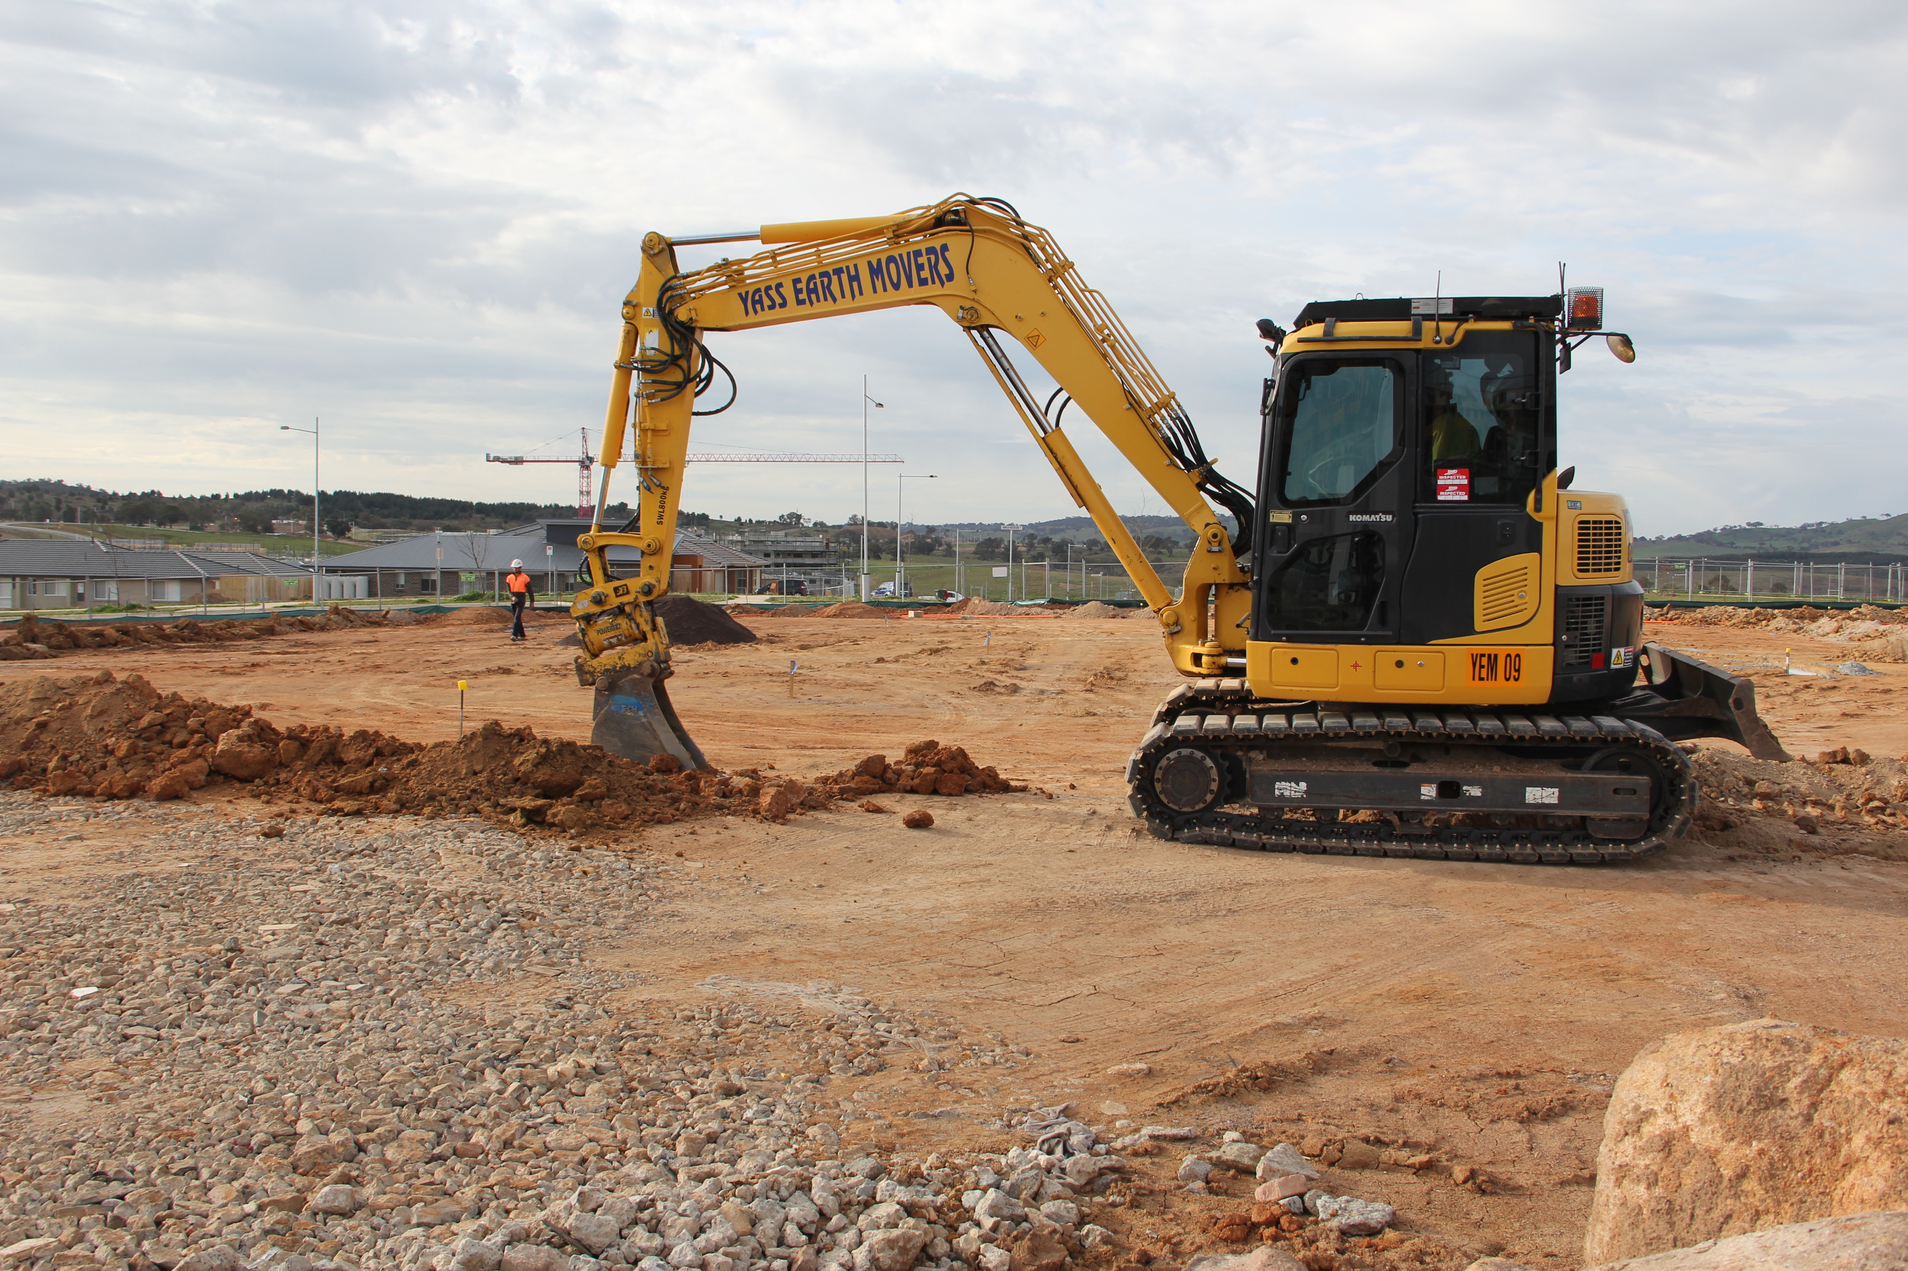 Land clearance for development at Wright
Photo: ACT Government
The number of development applications lodged with the ACT Government during 2011–2015 has remained relatively stable at 1100 to 1200 per year, and 1100 to 1700 residential development applications are exempt each year.

Response
The ACT Government manages land use and land-use impacts in the ACT in a variety of ways, the Planning and Development Act 2007 and the ACT Planning Strategy (2012) are both key to land management in the ACT. The Planning Strategy aims to address the challenges for the ACT in the face of continued growth of the city while maintaining important environmental values. One key aim of the Planning Strategy is that the proportion of new housing delivered through urban in-fill will be 50% or more.
Other strategies also address important aspects of land management; the ACT Nature Conservation Strategy 2013, for example, includes the development of an ACT soils strategy and other actions to improve knowledge of landscape function across the ACT (see ACT SoER 2015, Case Study 5.2).
The ACT community contributes to the health of our land through groups such as ParkCare and the development and use of community gardens which offer productive ways to use land that would be otherwise at risk of weed invasion, erosion and other degradation. The added vegetation also creates habitat values in the urban environment.
More information on this topic is available in the ACT State of the Environment Report 2015 http://reports.envcomm.act.gov.au/actsoe2015

