HUMAN NEEDS
The fundamental human needs for food, shelter and clothing have a significant impact on the environment including the production of waste and pollution. In modern societies our needs have expanded to include travel and communication over long distances, education, high quality health care and many other activities. To satisfy human needs we use the services provided by the natural environment, called “ecosystem services”, as well as our own industry and various technologies. Ecosystem services listed by the international Millennium Ecosystem Assessment (2005) include:
- provisioning services - the products we obtain from our ecosystems including food, fuel, genetic resources and natural chemicals and medicines
- regulating services - such as air quality maintenance, climate regulation, water purification and pollination of crops and other desirable vegetation
- cultural services - the non-material benefits such as cultural heritage, sense of place and outdoor recreation.

Measuring the pressure of human needs
Measuring our demands on the Australian Capital Territory (ACT) ecosystem services directly is difficult. However, relevant data on ACT population, income and wealth (linked to goods and services consumption); local industries; waste generation and recycling, are readily available. These, and results of expert research on our total ecological footprint, were taken as indicators for the Human Needs chapter of the ACT State of the Environment Report 2015.
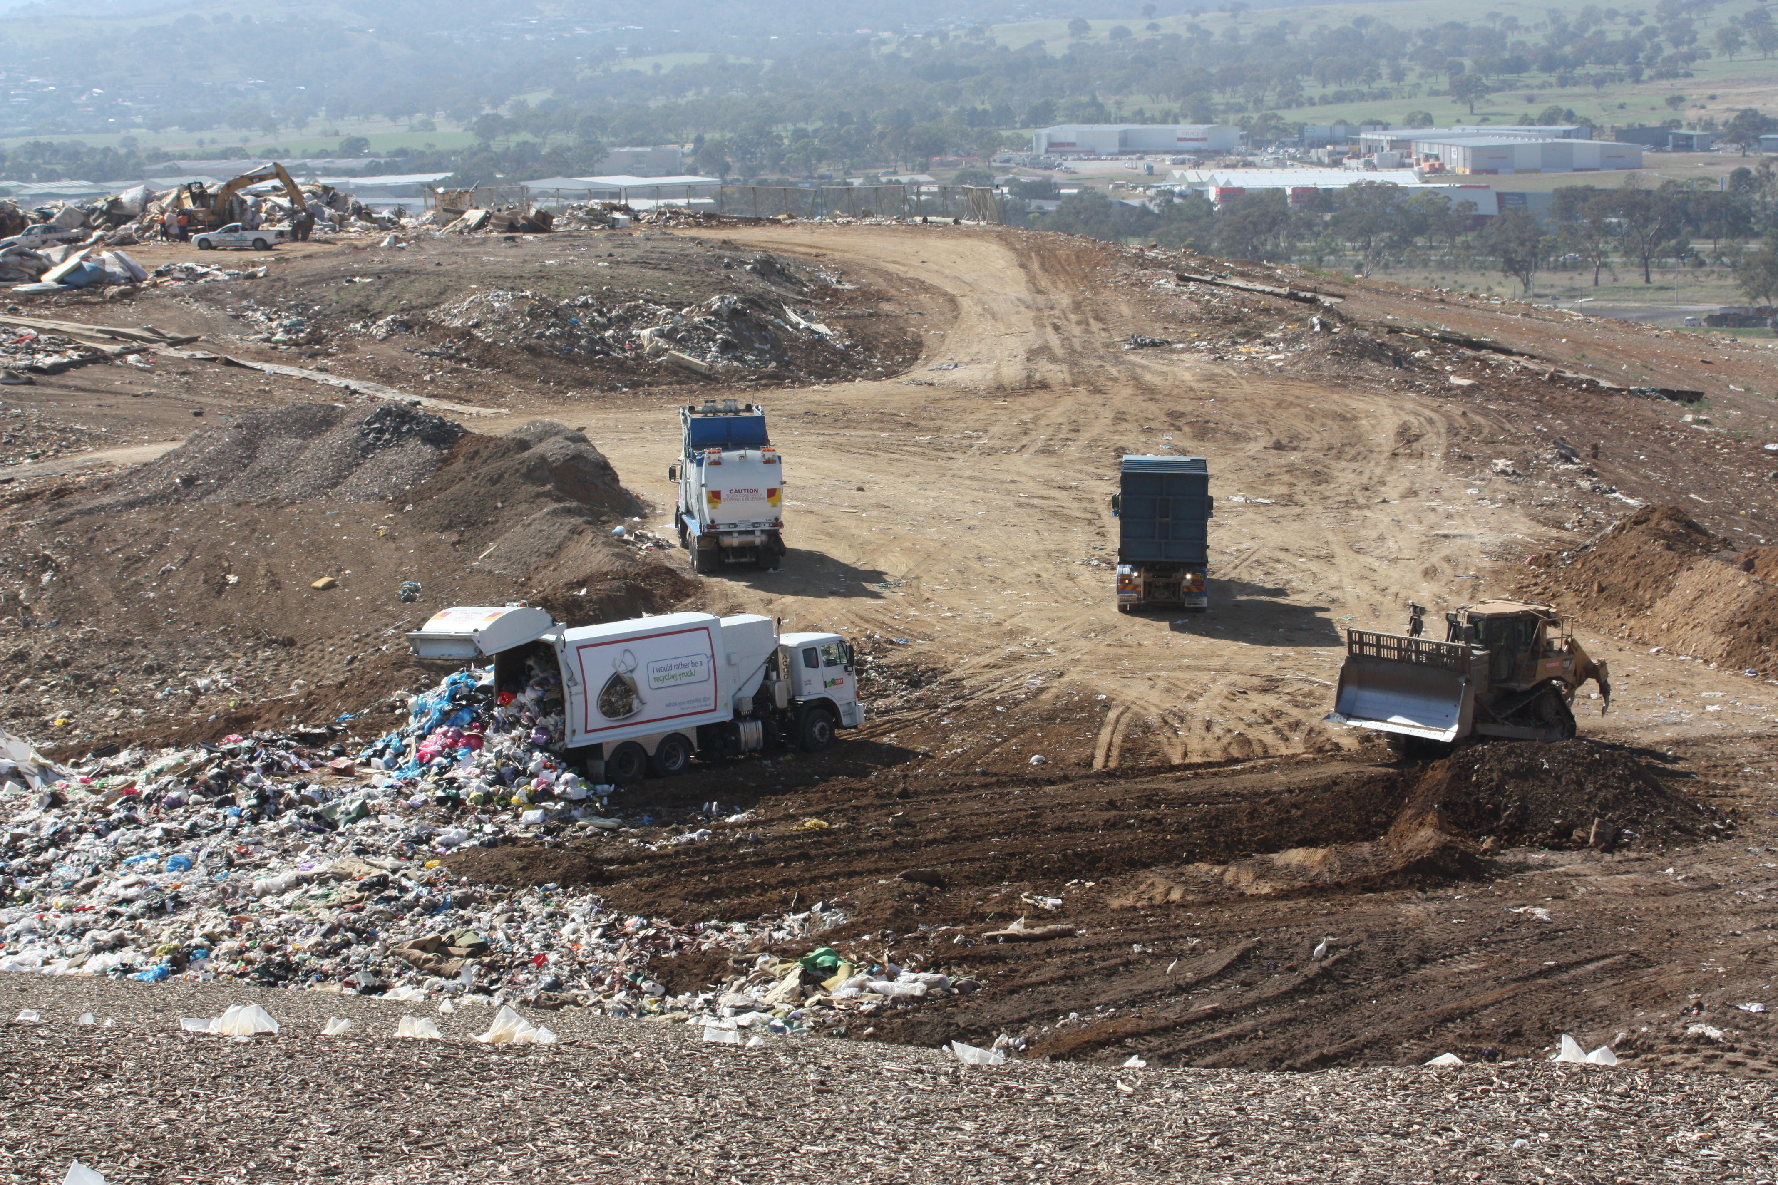
The land fill at Mugga Lane is one demonstration of our demands on the environment Source: ACT Government

Current pressures
- Population
- Income and wealth
- Composition of local industries
- Waste generation and recycling
- Ecological footprint

Future pressures
- Population growth

MAIN FINDINGS

State and trends
Population - At the end of the 2011- 2015 reporting period the ACT population had grown to around 390,000 and is on average younger than the Australian population.
Income and wealth - ACT workers have average weekly earnings around 14 % higher than other Australians, workforce participation and employment rates are high. Our average household net wealth is around 10% higher than the average for Australian households.
ACT industries - are heavily concentrated in the public administration and safety sector which employs 38% of our workforce (compared to 6.2% of the workforce for Australia overall) there are few industries with potentially large environmental impacts, such as mining and manufacturing.

Figure 1: ACT waste committed to landfill and recycled waste 1993-94 to 2014-15 (includes Queanbeyan)
Source: Territory and Municipal Services Directorate
Waste products - ACT residents and industries generate at least 2.2 tonnes of garbage per person every year. Combined with the waste from Queanbeyan which is put into ACT landfills, the total waste generated is over 900,000 tonnes each year. However 70% -75% of our solid waste is recycled (Figure 1).
Ecological footprint - This is a measure of the use of global land needed to provide for our needs. An assessment of our footprint for the 2015 SOER (using data for 2011-12) is that our footprint is 8.9 gha per person – slightly down on the previous assessment but higher than Australia and much higher than the world average (see separate fact sheet for details).

Pressures
The most recent ACT Government projections, from 2014, suggest that the ACT population will be around: 424,000 in 2020; 547,000 in 2040; 670,000 in 2060. As our population grows the attendant needs of ACT citizens are likely to increase, along with demands on ecosystem services inside and outside the ACT. To progress towards a more sustainable ACT, requires commitment and effort from all sectors of the community along with support for innovation, new technologies, far-sighted government policies and effective implementation.

Response to human needs and the pressure they put on the environment
The ACT Government has in place plans and policies to provide for human needs while managing the impact on our environment, under The Canberra Plan: Towards our second century (2008). The highest level plans are:
- ACT Planning Strategy (2012)
- Action Plan 2: A new climate change action plan for the Australian Capital Territory (2012)
- ACT Water Strategy 2014-44: Striking the Balance
- ACT Waste Management Strategy 2011 - 2025
- Transport for Canberra: Transport for a sustainable city 2012-2031
More information on this topic is available at http://reports.envcomm.act.gov.au/actsoe2015

