HERITAGE
Heritage consists of objects, places and even traditions that have special historical, natural or cultural value, and are preserved for and passed on to future generations. Heritage may include aspects of the environment, including land, water, ecosystems and items within them. The ACT has a wealth of heritage that extends from the long custodianship of the land by Aboriginal people to the growth of the modern capital city, Australian federation and government. In telling our story, is important not only for ACT residents, but all Australians.
Heritage places and objects of an area can provide a sense of the changing character of a place, provide ties to distant and more recent history and contribute to a sense of place and connection over time. Places of heritage value can also contribute to human wellbeing through employment opportunities and the economic benefits associated with tourism.
For Aboriginal people, access to, and valuing of, expressions of culture and heritage have been recognised as crucial components of physical and mental health.

Measuring the condition of heritage
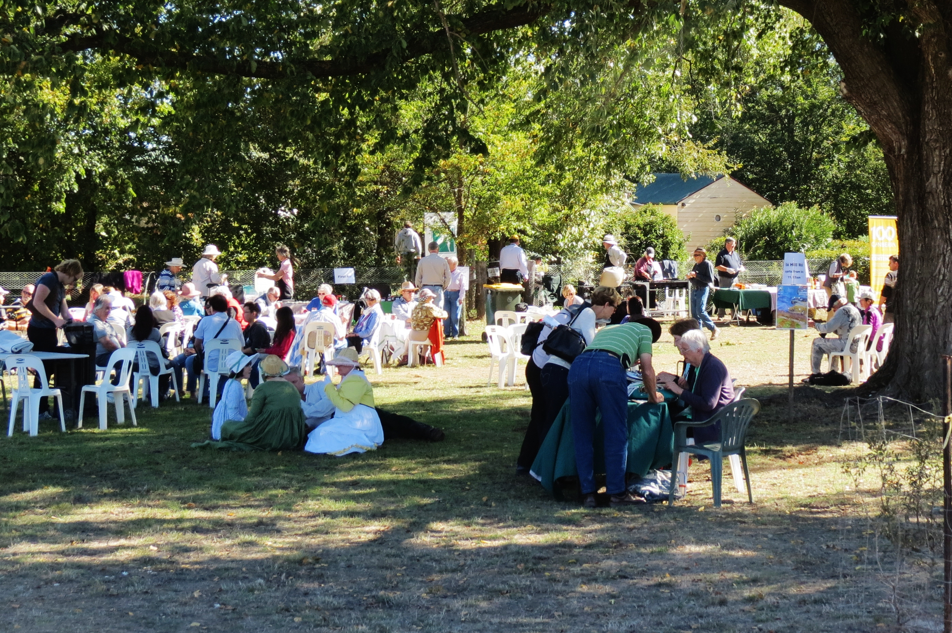
Elm Grove Open Day during the ACT Heritage Festival
Source: ACT Government

The ACT Heritage Register listing gives an overall view of the type and number of heritage places and objects known to occur in the ACT (data supplied by ACT Heritage). This allows an assessment of the state of heritage in the ACT to the degree that while something is registered, it is afforded protection. However the number of listed places and objects does not give a full picture of the state of heritage across the ACT, because the condition of heritage sites and places is not assessed.
The following indicators are used to assess state and trends and pressures:

State and trends
- Number of historic heritage places and objects on the ACT Heritage Register
- Number of Aboriginal places and objects on the ACT Heritage Register
- Number of natural heritage places and objects on the ACT Heritage Register
- Assessing trends in registration across this and recent reporting periods.

Pressures
- Changes in land use including urban development

MAIN FINDINGS

State and trends
- 414 historic places and objects are registered on the ACT Heritage Register, an increase of 63 since the end of the previous State of the Environment reporting period in 2011.
- 72 ACT Aboriginal heritage places or objects are registered, an increase of five since 2011 with a further four places or objects nominated.
- All Aboriginal heritage places and objects in the ACT are protected under the Heritage Act 2004, regardless of whether they are listed on the ACT Heritage Register. These are expected to number around 3000 sites.
- Nine natural heritage places or objects are on the ACT Heritage Register, compared with six by the end of the previous reporting period. Although the number is low, the geographic coverage of these areas is relatively large. Two of the new registered natural heritage sites are Kama Woodland and Hume Paleontological Site.
- There have been a further 31 nominations of natural heritage places for the ACT Heritage Register with during the reporting period.
Under the Heritage Act, the ACT Government is obliged to report every three years on the condition of assets it owns. Apart from these assets, the condition of heritage places and objects is not monitored. As a result, no assessment of asset condition can be made in this report.

Pressures
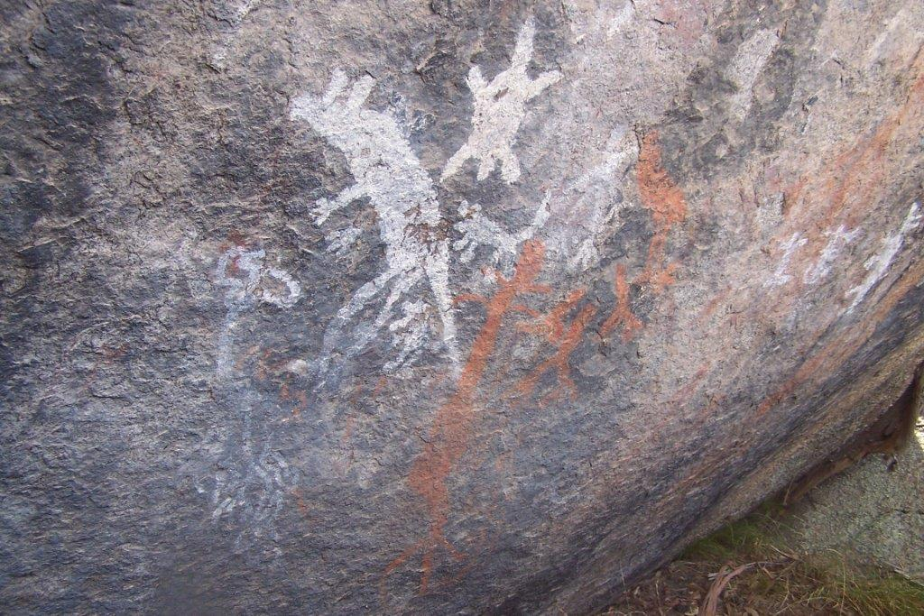
Land use change and development are the most significant pressures on heritage sites and objects in the ACT. Urban infill mainly affects historic heritage, while greenfield development mainly affects natural and Aboriginal heritage. Although Aboriginal artifacts are preserved and moved when found on a development site, many Aboriginal people still see the heritage as lost, because the link between the artifact and place has been disrupted. To address this, the ACT Government is developing an Aboriginal cultural heritage assessment policy.
Aboriginal rock art at Yankee Hat, Namadgi National Park.
Source: ACT Government

Response
Heritage places and objects in the ACT are protected under the Heritage Act 2004. The Heritage Act states that the following types of heritage are to be recognised, registered and conserved:
- places and objects that have natural heritage significance
- places and objects that have cultural heritage significance
- Aboriginal places and objects.
The ACT Government has a number of structures and policies in place to protect ACT heritage values. The main organisations are ACT Heritage within the Environment and Planning Directorate, the ACT Heritage Council, and the Heritage Advisory Service. In addition, the Government develops infrastructure and events to support community understanding and appreciation of ACT heritage, such as signage and Heritage Grants for conservation management. A new five year (2016 – 2021) heritage strategy is planned with public consultation to commence in early 2016.
More information on this topic is available in the ACT State of the Environment Report 2015 http://reports.envcomm.act.gov.au/actsoe2015

