THE ACT ECOLOGICAL FOOTPRINT
An ecological footprint is a calculation of the amount of land and water required to support demand for goods and services and our use of resources. It also takes into account the area needed to absorb our waste (including greenhouse gasses). The ecological footprint provides a calculated measure of the extent of human impact on the earth, determines our relative consumption of global resources, and helps us understand the link between our lifestyles and the environment; providing us with a means by which to assess the sustainability of our lifestyle.

Measuring the ecological footprint of the ACT
Since 1997 ACT ecological footprint reports have accompanied our State of the Environment Reports (see http://www.envcomm.act.gov.au/ecological-footprints). The most recent report was prepared for the ACT State of the Environment Report 2015 by Dr Chris Dey, Integrated Sustainability Analysis (ISA) research group, University of Sydney.

How was the assessment made?
The ISA has assembled a framework for calculating Ecological Footprints tailored to Australian conditions. This framework employs the most detailed and comprehensive information on land disturbance and greenhouse gas emissions available in Australia today, using the Australian Bureau of Statistics’ (ABS) comprehensive input-output tables, and the CSIRO’s satellite-image-based assessment of land disturbance over the Australian continent. The assessment offered by ISA guarantees full coverage of all upstream impacts on land and emissions, and is therefore the only complete Ecological Footprint assessment to date. This ecological footprint analysis of the ACT covers the financial year 2011-12 and meets international standards in Ecological Footprinting.

MAIN FINDINGS
The main determinant of an ecological footprint is usually the level of household consumption. According to Dr Dey’s analysis consumption grew more slowly in Australia in the aftermath of the 2008 global financial crisis owing to slowing of increases in household incomes and higher household saving rates. Our ecological footprint can be examined from a number of different perspectives; Figure 1 presents our footprint by consumption category, showing that Canberrans ‘spend’ their footprint predominantly in Services and Food.

Figure 1: ACT Ecological footprint per person by consumption category 1998-99 to 2011-12

Our ecological footprint can also be broken down to show the types of productive land that are used to absorb our environmental impacts. Some impacts can be seen and measured locally, such as the land we cover with our buildings and roads and the garbage we send to landfill. But most of our impacts occur outside the ACT through the production of goods and services that we consume here and the land needed for vegetation to absorb our carbon dioxide emissions (Figure 2).

Figure2: ACT Ecological footprint per person 2003-04 to 2011-12 compared to Australian footprint 2011-12, by land type

At a finer scale, we can observe the composition of our ecological footprint in the below analysis of the top 300 commodities consumed by Canberrans. The first twenty-five out of the 300 commodities account for two thirds (67%) of the total Ecological Footprint, which are displayed in Table 1 below.
Rank | Commodity | Impact (gha/capita) | % of Total
1 | Electricity supply | 1.01 | 12%
2 | Hotels, clubs, restaurants and cafes | 0.46 | 6%
3 | Petrol | 0.41 | 5%
4 | Gas supply | 0.33 | 4%
5 | Air and space transport | 0.31 | 4%
6 | Other food products | 0.23 | 3%
7 | Ownership of dwellings | 0.22 | 3%
8 | Beer and malt | 0.19 | 2%
9 | Clothing | 0.19 | 2%
10 | Wooden furniture | 0.18 | 2%
11 | Finished cars | 0.18 | 2%
12 | Beef cattle | 0.17 | 2%
13 | Education | 0.16 | 2%
14 | Non-building construction | 0.14 | 2%
15 | Non-residential building construction | 0.14 | 2%
16 | Electronic equipment | 0.13 | 2%
17 | Recorded media and publishing nec | 0.12 | 2%
18 | Wheat | 0.12 | 1%
19 | Joinery products | 0.12 | 1%
20 | Meat products | 0.12 | 1%
21 | Community services and religious organisations | 0.12 | 1%
22 | Accommodation | 0.11 | 1%
23 | Cakes | 0.11 | 1%
24 | Federal government | 0.10 | 1%
25 | Fresh meat | 0.09 | 1%
Table 1: Top 25 commodities in terms of per-capita Ecological Footprint in the ACT in 2011-12.
Key results of the 2011-12 Report were that the average ecological footprint of Canberrans was 8.9 global hectares per person (gha/person) and:
- about three and a half times the global per person average
- above the average per person ecological footprint of other Australians (8.2 gha/person)
- slightly lower than the ACT footprint measured in 2008-09 (9.2 gha/person, perhaps as a result of the Global Financial Crisis in 2008).
In short, Canberrans impact the global environment more than people in most places on earth. Although our footprint per person has moderated very slightly since the last report, our total footprint is about 14 times the land area of the ACT. Despite the marginal reduction in the overall footprint from 2008-09 this most recent report indicates a continuing trend of increasing impact on our ecological systems and their capacity to sustain us.

Why does an increasing footprint matter?
We only have one Earth. Using our natural capital (our finite or slowly regenerating natural resources) faster than it can be replenished is like maintaining spending that continually exceeds income. This results in shrinking forests, biodiversity loss, freshwater stress and climate change. All of these impacts have an impact on us, which may not be immediately felt but certainly impact us in the future.
There are also social and economic costs. In a world with limited resources, excessive consumption by some will have a negative impact elsewhere and on other people. If we in wealthier countries continue our current consumption patterns, we put pressure on others to live in poverty without sufficient resources to sustain life and health. Our ecological footprint is a social and economic issue as much as it is an environmental one.

What can Canberrans do to reduce our footprint?
The ACT is not self-contained; the resources that we consume come from across the world. Reducing our ecological footprint requires actions that take into account the resources we use, not just in the ACT but nationally and globally. Key actions are to:
- Be smarter in our consumption, and
- Protect and enhance our national environment so our land and water is biologically more resilient and productive.
Key decisions that Canberrans can make on a daily basis to reduce our footprint include:
- Repair, reuse or borrow where possible instead of buying new things;
- Before tossing something in the bin see if there is another use for it;
- Buy quality goods that are efficient and will last a long time;
- Invest in doing an activity as an alternative to purchasing goods. e.g. Concerts, movies etc.
- Use renewable energy; and
- Make your home and appliances more energy efficient.

Larger changes need to be made through government policy and the support of the wider community and business sector include;
- Transforming our economies to lower our overall resource use;
- Improving the efficiency and sources of our energy;
- Pursuing further regional opportunities to extend the production of renewable energy;
- Supporting business initiatives towards an expanded ‘green economy’; and
- Protecting and enhancing our natural environment.
The ACT Commissioner for Sustainability and the Environment is about to launch the 2015 ACT State of the Environment Report. The Report will present an update on the 2008-09 ecological footprint data, and will further discuss the consequences of our increasing footprint in the ACT. The 2015 Report will also highlight actions in the period since the 2011 SoER that are making a difference, and where we will need to focus our efforts in the future.

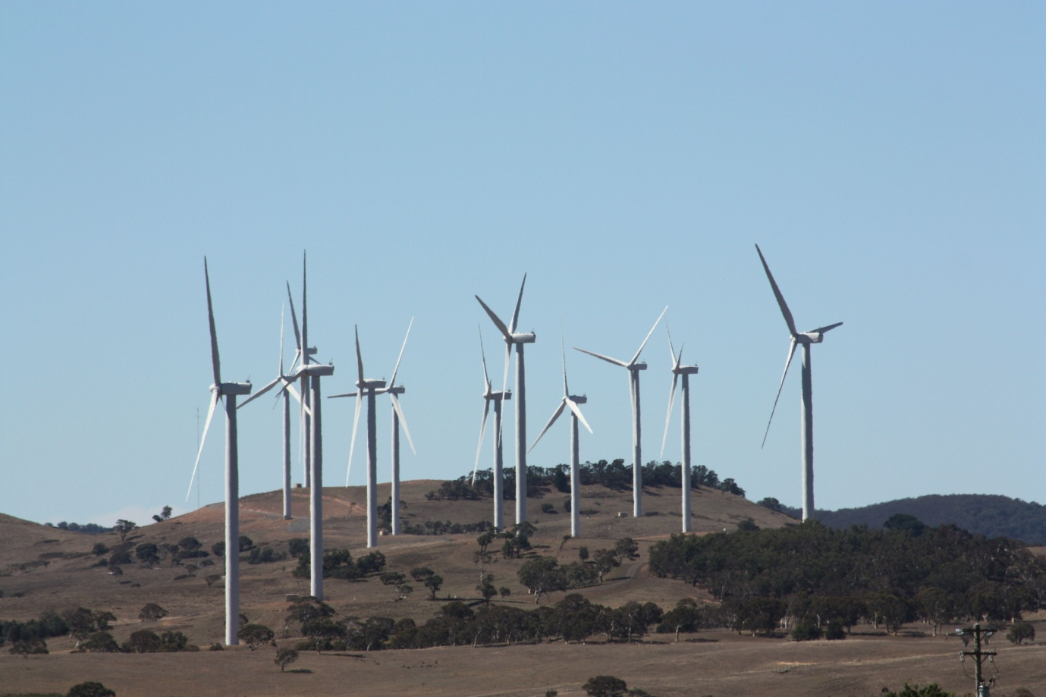
Windfarms near Canberra. Photo: ACT Government

More information on Canberra’s ecological footprint is available on the OCSE website, located at the following link; http://www.environmentcommissioner.act.gov.au/ecological-footprints
Additional information is available in the 2015 ACT State of the Environment Report, located at the following link; http://reports.envcomm.act.gov.au/actsoe2015

