# COMMISSIONER’S MESSAGE:

The key messages from the 2015 *State of the Environment Report* (SoER) for the Australian Capital Territory (ACT) are positive. Overall, the ACT environment is in good condition and it is well managed. On the defining issue of climate change, the ACT community has supported its government to act locally and show leadership that can inspire other jurisdictions to commit to action.

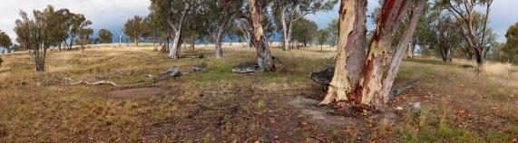

Kama Nature Reserve. Courtesy: A. Tatnell, PCS Collection

## The Report

This evidence-based report by the ACT Commissioner for Sustainability and the Environment captures and presents key information on the state of the ACT environment. It undertakes the important task of collating the best information available and then standing back to assess how our environment is faring on our watch.

The report provides an assessment of the state and trends of key environmental indicators, pressures on the environment, drivers of those pressures and their impacts. It also examines management initiatives in place to address environmental concerns and the effect of those initiatives. A new component of the report is an assessment of the resilience of ecosystems services provided by the environment to the people of the ACT. This assessment evaluated the capacity of our local environment to continue to provide services such as clean water, air, stable and healthy soil, and a diversity of flora and fauna integral to achieving sustainability in the ACT.

## Human needs and climate change drive environmental change

The context for the report is an increasingly highly modified natural environment. Human impact has reached even the most remote areas of wilderness and climate change poses a significant threat. By far the most significant challenge to the environment that supports life on our planet is climate change. This is a challenge that requires decisive action at local, city, state and global scales. We must manage these threats and impacts and we cannot wait until we have perfect information before acting. What we can do is work with the best information available. The ACT is in the fortunate position of having an incredible wealth of scientific and practical environmental expertise. We are generally well placed to make informed decisions while continuing to build our knowledge base and recalibrating our actions. This ‘adaptive management’ approach is a logical, rational and cost-effective way to proceed.

## OVERALL FINDINGS

The people of the ACT should be proud that they have supported significant and leading action on climate change. The ACT Government has committed to achieving targets of meeting 100% of its energy consumption needs with renewable energy by 2025 and reducing the ACT’s greenhouse gas emissions 40% below 1990 levels by 2050. To achieve these targets, we must all lend strong and unwavering support and follow through on commitments and action to reduce our emissions in the face of social, economic and political changes. As a community, we must also continue to value scientific evidence and work actively with partners in other jurisdictions and other nations.

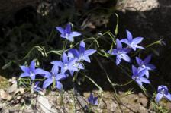

The Royal Bluebell- Canberra’s Floral Emblem. Photo: M. Fagg Australian National Botanic Gardens

The local environment has, in general, been managed well using an adaptive management approach and with the support of large numbers of committed ACT residents, such as ParkCare volunteers. There is also evidence of efforts to address concerns and issues raised by past Commissioners. For example, In line with recommendations in the 2011 State of the Environment Report, the ACT Government has taken action to improve sustainability by developing major strategies including the Climate Change Strategy, Action Plans and Greenhouse Gas emission targets legislation, the Water Strategy, the Nature Conservation Strategy, the ACT Planning Strategy, Transport for Canberra and the ACT Waste Management Strategy.

## RECOMMENDATIONS – for Government

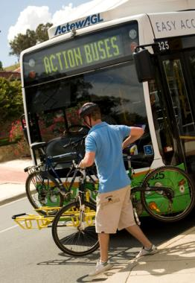Nevertheless, there are some areas where the report’s assessments of air, land, water, biodiversity and heritage show that management decisions are not always resulting in improvements to environmental outcomes. Where it is consider there is still work to be done, recommendations have been made to the ACT Government. These areas include:

* Considering integrated monitoring, reporting and evaluation all the key environmental strategies
* Ensuring the new climate change adaptation strategy is best practice
* Making more use of strategic environmental assessments to reduce and manage cumulative and cross-sectoral impacts on the environment, and considering air quality impacts of future urban developments
* Resourcing foundation-knowledge development including monitoring of landscape function and soils and the effectiveness of conservation programs and improving biodiversity conservation data collection and storage

Bike and ride Photo: ACT Government

* Assessing drivers of the poor condition of water resources as shown by the indicators for total nitrogen, turbidity, chlorophyll-a and ecological biodiversity and the need for more data, and
* Commencing a program, in cooperation with the act heritage council, to assess and monitor the condition of heritage places and objects on the act heritage register.

## OUR LONGER TERM CHALLENGE – for the community

Reducing the global environmental impact of our consumption stands out as a major long-term challenge that requires investment and commitment to changing behaviour across all sectors of our society and our economy. It is not readily tackled by governments alone. As a well-educated and affluent community we understand that our lifestyle choices will shape the environment that our children and grandchildren will live in. Our choices profoundly affect the ecological services that our environment can provide for us and them, now and into the future.



**ACT ecological footprint per capita (2003-04, 2008-09 and 2011-12) and average Australian ecological** **footprint, 2011-12 Source: Dey, 2015**

It is estimated that the average ACT resident had an ecological footprint of 8.9 global hectares in 2011-12, which is three and a half times higher than the world average and five times higher than the average available biocapacity. As most of the goods and services consumed by ACT residents are imported from outside our jurisdictional boundaries the ACT’s ecological footprint extends into other parts of Australia and to countries overseas.

If we are to reduce our ecological footprint and the demands on ecosystem services, we must, as individuals and as a community, make considered and informed choices in our everyday lives about our levels and patterns of consumption. For our community the long-term challenge then becomes:

* To find better ways of seeking out the goods and services that can be delivered in the most footprint-efficient way. This could mean choosing products that are energy and water efficient to use, durable, and recyclable when they are no longer useable
* To seek out alternatives to consuming products including cultural, community and sporting and volunteer activities such as park care and land care
* To support a community focus on a range of leisure activities for all age groups to help make spending time being active more attractive than spending money on non-essential goods.

In the longer term, these are the kinds of responses needed from all of us to ‘future proof’ our community in the face of climate change and the increasing pressures we are placing on the earth’s ecosystems. By acting individually and as a community and supporting government action, we can transform our society in a safe, fair and manageable way to a new more sustainable future.

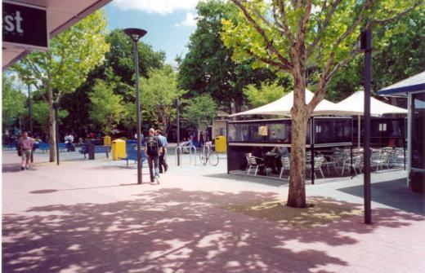

**Garema Place, Canberra City Photo: ACT Government**

More information on this topic is available in the *ACT State of the Environment Report* 2015 <http://reports.envcomm.act.gov.au/actsoe2015>