WHAT DOES THE CHANGING ENVIRONMENT MEAN?
The 2015 State of the Environment Report (SoER) explores the interactions between humans and the environment, and attempts to answer:
- What impacts do humans have on ecological systems?
- What benefits do humans derive from these systems?
- How susceptible are coupled socioecological systems to shocks, which might mean they could no longer function in ‘desirable’ ways?
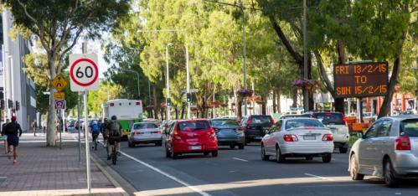
The amount of time residents spend travelling each day affects the livability of a city. Source: ACT Government

The amount of time residents spend travelling each day affects the livability of a city. Source: ACT Government

How did we answer these questions?
The Report answers these questions through indicative and preliminary assessments on:

Livability
- How attractive the ACT is compared with other places in perceived quality of life

Ecosystem services
- The ways the environment provides goods and benefits which support and fulfil lives of people in the ACT

Resilience
- How well the coupled socioecological systems in the ACT might be able to cope with expected and unexpected pressures and shocks without losing their essential characteristics.

MAIN FINDINGS

Livability
Livability is the combination of factors that contribute to people’s quality of life and wellbeing.
The report considers overall indices of liveability, including:
- Access to green infrastructure and open space
- The built environment, such as housing, connectivity, transport and congestion
- Human health as affected by the built physical and natural environments
- Government management contributing to liveability
Excellent access to nature reserves, open space and green infrastructure like urban parks and wetlands, fresh air and water, good health outcomes and low congestion contribute to the ACT’s high livability as measured by a number of international and national indices.

Challenges include managing water quality, improving public and active transport options, ensuring affordable housing, especially for low-income residents, and maintaining good-quality urban spaces. The ACT Government has put in place important framework strategies and made significant investments to address climate change, health improvement, and public and active transport.

Ecosystem services
Ecosystem services are the ways in which processes in ecological systems (ecosystems) contribute to human social and economic wellbeing. They include the provision of water, food from primary production and agriculture, recreation and tourism opportunities and many others.
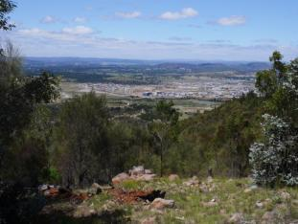Canberra has a mixture of housing types, as well as a mix of infill and Greenfield development. Photo: Office of the Commissioner for Sustainability and the Environment
The ACT SoER 2015 assessment of the state of services for air, land, water, biodiversity and heritage shows a generally positive situation, largely because of the high proportion of land under conservation tenure. The ACT also has generally good air and surface water quality, and land and heritage protection. However, pressure on these ecosystem services from incremental change is potentially a concern and needs to be managed carefully. Urban development, degradation from pest species, fire and erosion are all elements that will require management if essential ecosystem services are to be maintained.

Resilience
Resilience is the ability of a system to respond and adapt to pressures and shocks yet retain key desirable and valued characteristics. The ACT SoER 2015 asks the question: ‘Does the ACT have the resources, monitoring, feedback and networks in place to identify and respond rapidly and effectively to changes that threaten the natural and urban environment that people value?’

Overall, the assessment found that the ACT has good socioecological processes in place to maintain much of what is valued. The ACT has performed very well against targets for reserving comprehensive, adequate and representative samples of ecosystems, a significant risk mitigation strategy for resilience. As in other jurisdictions in Australia and overseas, many gaps are apparent in our understanding of changes affecting our climate, land, biodiversity and human needs, as well as our capacity to adapt to them.

More information on this topic is available in the ACT State of the Environment Report 2015 http://reports.envcomm.act.gov.au/actsoe2015

